By
Graham Hosking
Illustrated by Inky Stone
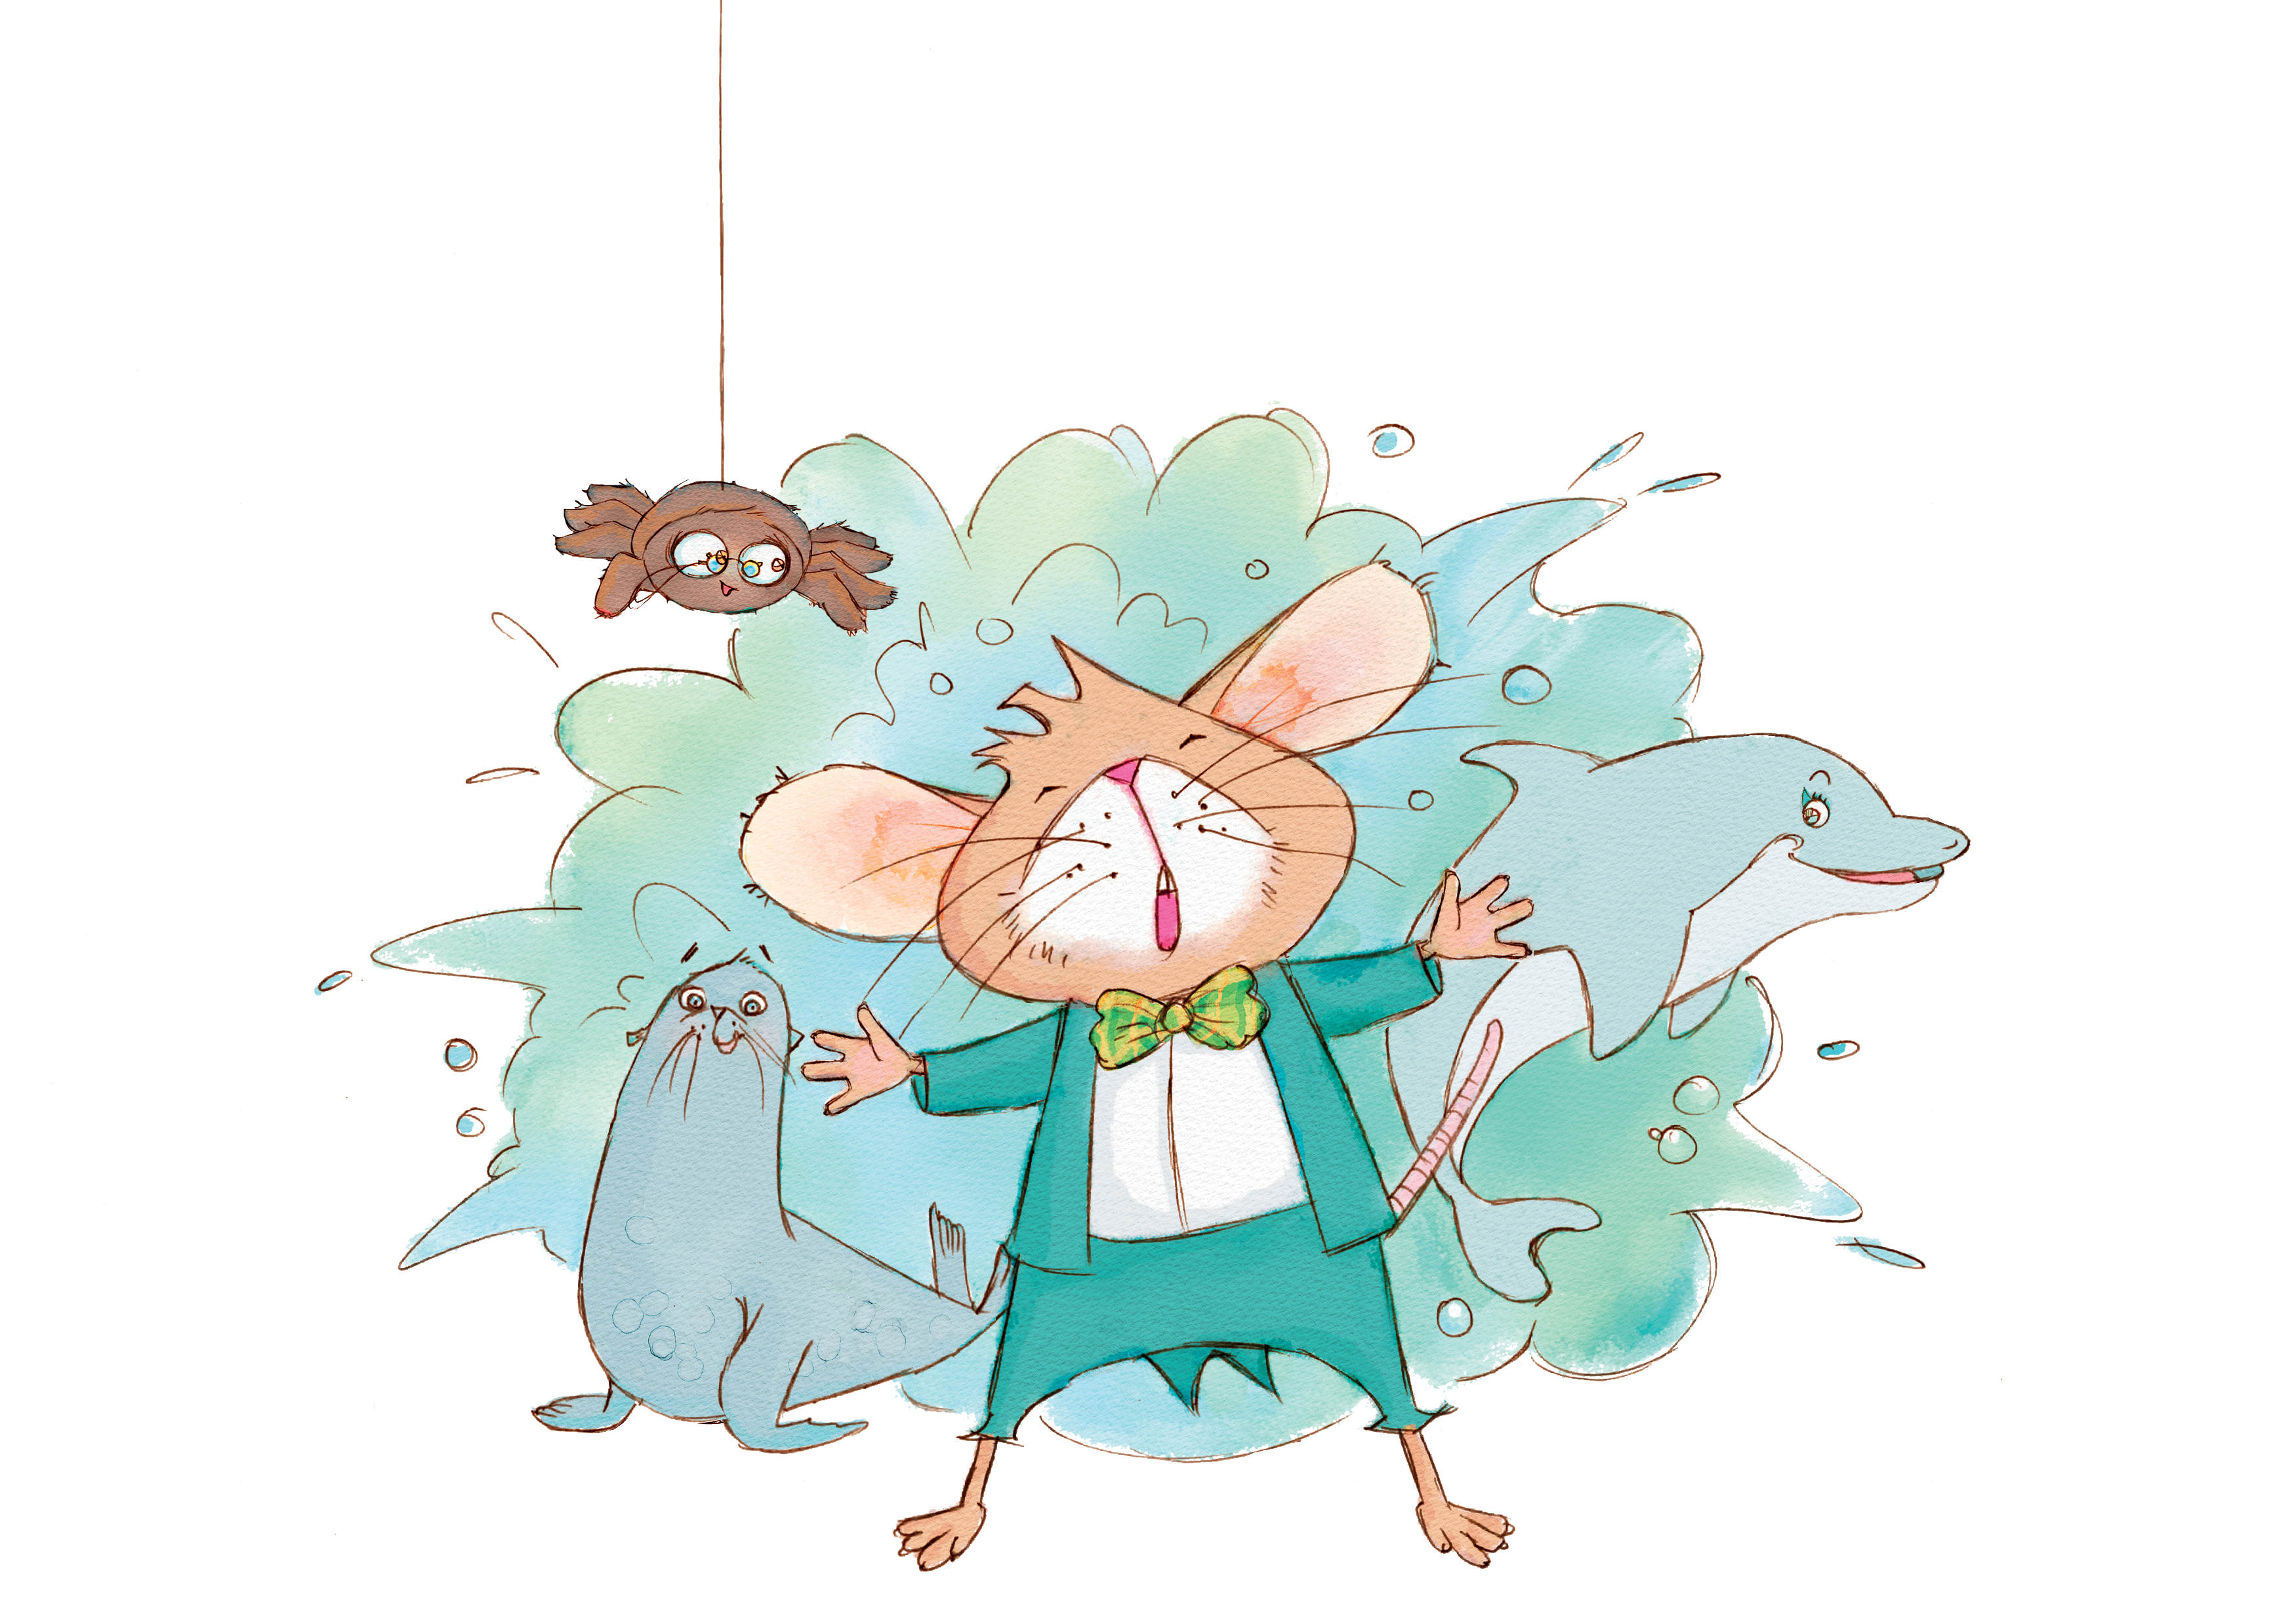
Teacher Notes
Written by Vanessa Ryan-Rendall

Contents
Book summary 3
About the Author 3
Reasons for studying this book 4
Themes 4
Links to the Australian Curriculum 5-6
Teaching and learning activities 7-16
Worksheets to link with activities 17-18

Sidney Opera Mouse
by Graham Hosking and illustrated by Inky Stone

Book summary

Sidney was a little mouse who lived inside a cage. A pet shop found in Sydney’s north was where he spent his days.

Can Sidney escape the pet shop and pursue his dreams? With courage and a little help from his new friends, he may just find the place he is destined to belong.

Author Bio

Ever since I was little I’ve been a fan of stories. I am not so little anymore but I am still in awe of the power that books have to inspire, teach and entertain. Great books can transport you into other worlds, spark conversations, inspire creativity, offer comfort, teach valuable life lessons and of course entertain.

I was born in Sunderland in the North East of England but I spent most of my childhood in Knutsford in the north-west, where I attended Primary School, the local High School and then University College Chester.

In 2013 an opportunity arose to move to Sydney, Australia which I grabbed with both hands.
In 2016, an idea for a book popped into my head and I put pen to paper. With hard work and plenty of support -the idea became a reality in 2019 when “Sidney Opera Mouse’” launched.

I continue to write stories infused with adventures and plan on launching more books soon - all with the aim to make people laugh and smile.

Reasons for studying this book

This book is written in rhyme that is easy to follow and understand. Students can learn about rhyme through this playful picture book and the use of beat and rhythm within each stanza.

Sidney, the main character struggles with belief in his own abilities so this book is a great talking point to discuss how important it is for us to realise what we are good at.

Children can explore the city of Sydney through this picture book and the idea that travel can open up our minds as we meet new people and see new places. It is a great way to link in geography, distances and different modes of transport.

Themes

Sydney Travel Adventure Rhyme

Self-belief Friendship Resilience

Link to curriculum

Literacy

Early Stage One (Kindergarten – ages 4-6)

- Recognise and generate rhyming words, alliterationpatterns, syllables and sounds (phonemes) in spoken words(ACELA1439)
- Recognise that texts are created by authors who tell stories and share experiences that may be similar or different to students’ own experiences (ACELT1575)
- Identify some features of texts including events and characters and retell events from a text (ACELT1578)
- Recognise some different types of literary texts and identify some characteristic features of literary texts, for example beginnings and endings of traditional texts and rhyme in poetry (ACELT1785)
- Replicate the rhythms and sound patterns in stories, rhymes, songs and poems from a range of cultures (ACELT1579)
- Listen to and respond orally to texts and to the communication of others in informal and structured classroom situations (ACELY1646 )

Stage One (Year One and Two – ages 6-8)
- Discuss features of plot, character and setting in different types of literature and explore some features of characters in different texts (ACELT1584)
- Listen to, recite and perform poems, chants, rhymes and songs, imitating and inventing sound patterns including alliteration and rhyme (ACELT1585)
- Recreate texts imaginatively using drawing, writing, performance and digital forms of communication(ACELT1586 )
- Discuss the characters and settings of different texts and explore how language is used to present these features in different ways (ACELT159 )
- Identify, reproduce and experiment with rhythmic, sound and word patterns in poems, chants, rhymes and songs(ACELT1592)
- Innovate on familiar texts by using similar characters, repetitive patterns or vocabulary (ACELT1832)
- Create events and characters using different media that develop key events and characters from literary texts(ACELT1593 )
- Innovate on familiar texts by experimenting with character, setting or plot (ACELT1833 )

Stage 2 (Year Three and Four – ages 8-10)

- Discuss texts in which characters, events and settings are portrayed in different ways, and speculate on the authors’ reasons (ACELT1594)
- Discuss how language is used to describe the settings in texts, and explore how the settings shape the events and influence the mood of the narrative (ACELT1599 )
- Discuss the nature and effects of some language devices used to enhance meaning and shape the reader’s reaction, including rhythm and onomatopoeia in poetry and prose(ACELT1600 )
- Create imaginative texts based on characters, settings and events from students’ own and other cultures using visual features, for example perspective, distance and angle(ACELT1601 )
- Create texts that adapt language features and patterns encountered in literary texts, for example characterisation, rhyme, rhythm, mood, music, sound effects and dialogue(ACELT1791 )
- Read and write a large core of high frequency words including homophones and know how to use context to identify correct spelling (ACELA1780 )
- Discuss how authors and illustrators make stories exciting, moving and absorbing and hold readers’ interest by using various techniques, for example character development and plot tension (ACELT1605 )
- Create literary texts by developing storylines, characters and settings (ACELT1794 )

Stage 3 (Year five and six – ages 10-12)

- Understand, interpret and experiment with sound devicesand imagery, including simile, metaphor and personification, in narratives, shape poetry, songs, anthems and odes(ACELT1611 )
- Create literary texts using realistic and fantasy settings and characters that draw on the worlds represented in texts students have experienced (ACELT1612 )

Humanities and Social Science

Early Stage One (Kindergarten – ages 4-6)

- Pose questions about past and present objects, people, places and events (ACHASSI001 )
- The representation of the location of places and their features on simple maps and models (ACHASSK014 )
- The reasons why some places are special to people, and how they can be looked after (ACHASSK017)

Stage One (Year One and Two – ages 6-8)

- Pose questions about past and present objects, people, places and events (ACHASSI018 )
- The natural, managed and constructed features of places, their location, how they change and how they can be cared for (ACHASSK031 )
- Activities in the local place and reasons for their location(ACHASSK033 )
- The history of a significant person, building, site and/or part of the natural environment in the local community and what it reveals about the past (ACHASSK044 )

Stage Two (Year Three and Four – ages 8-10)

- Pose questions to investigate people, events, places and issues (ACHASSI052)
- Locate and collect information and data from different sources, including observations (ACHASSI053)
- Pose questions to investigate people, events, places and issues (ACHASSI073 )
- Sequence information about people’s lives and events(ACHASSI076 )

Stage 3 (Year five and six – ages 10-12)

- Develop appropriate questions to guide an inquiry about people, events, developments, places, systems and challenges (ACHASSI094)
- Locate and collect relevant information and data from primary sources and secondary sources (ACHASSI095)
- Examine different viewpoints on actions, events, issues and phenomena in the past and present (ACHASSI127 )

Teaching and Learning activities

Before you read

See
- Look at the front cover - Who is Sidney? Who are the other characters and what is happening?

Think

- Explore the play on the word ‘Sidney’. (You might briefly discuss homophones/homonyms but this can be a lesson after you have read the story)
- Who is the author and illustrator?
- Read the blurb and discuss what it is telling us. (will there be one?)

Wonder
- What might happen in this story?
- What is an opera mouse?

As you read

These are some simple questions that you may like to use as you read the book to draw students attention to different pictures, words and ideas. Some of these questions can also be drawn upon after the story has been read.

Page 2
- What do the posters on the wall suggest?
- What is stopping the animals from escaping
- Do the animals look happy or sad?
- What colour is the snake and the frog?
- How many padlocks can you count?

Page 5
- What colour are the trees?
- What is the name of the tree ?
- There is glass on the floor near the door - why might that be?
- Sidney is running away from the pet shop - where is he running to?
- Describe the weather on this page.
Pages 6 & 7
- What is the name of the bridge in the picture?
- When was the bridge built?
- What are the two flags on top of the bridge?
- How many birds can you see?
- What can you see next to the flags in the picture?
- What are these people doing?

Pages 8 & 9
- How many birds can you see?
- What are the people doing?
- What are the straps on their costumes used for?
Page 10
- What is the tall building in the background ?
- What is the name of the black-and-white bird often seen in Sydney?
- How many birds in total can you see in the picture?
- On this page Sidney is exploring a park in the city. What is the name of this park?

Page 11
- Can you point out the Sydney Tower on page 11?
- Who is Sidney speaking to?
- What is the yellow object in the image?
- What is it used for?
Page 12
- Sam is a Spider - can you name any different types of spider?
- Why does Sam struggle to play the drums?
- Can you think of another instrument he may be better suited to playing?
Page 13
- There is a white bird sitting on a signpost. What is the name of this bird?
- How many people are there on the bus?
- Where is the bus heading to?
- How many birds are on the page?
Page 14 & 15
- Can you find the lifeguard tower and the lifeguards?
- What do lifeguards do?
- Can you find the red and yellow flags on the beach? What do they mean?
- How many surfers can you spot?
- What is the building on the right side of the page?

Page 16 & 17
- How might Sidney feel in this picture?
- How would you describe Sidney’s actions?
- What steps should Sidney have taken before getting in the water?
Page 18 & 19
- What is the name of the ferry?
- How many different ferries are there and what are their names?
- What unexpected animal can you see riding the ferry?
- What is the building on page 19?
- What is the animal sitting on the steps?
- How many birds can you see in this picture?
- What colours can you see on these pages?

After you have read

Literacy: Rhyme

Activity
This entire story is written in rhyme.

Look at the first page

Sidney was a little mouse who lived inside a cage.
A pet shop found in Sydney’s north was where he spent his days.
He had no chance to run around, had little room to play.
The shop was damp and gloomy, it was dark and cold and grey.

Circle the rhyming words, discuss how the sentence flows and the rhythm.
You can read the sentence and clap along to show how the sentences also have the same beat.

Break students into groups and give each student a different page of the book. (pages can be reproduced for educational purposes)

Ask students to note the rhyming words that are on the page.

Ask students to imagine what Sidney’s new life might be like. Brainstorm some ideas together using the Think-Pair-Share routine. (think alone, pair with one other and share ideas, share with the wider group)

Students then create their own rhyming stanza, using the page they have investigated as inspiration for length of sentence and rhythm.

Students create a paragraph about Sidney and his new life in the Opera House. It could be about what he gets up to during the day, the friends he makes or the food he eats.

Activity – Rhyming cards

Using the cards at the back of the notes, cut out and arrange the cards in random order. Students then need to pair up the rhyming pairs and make two rhyming sentences using these words as the last of each sentence.

Activity – Un-rhyming

Try to rewrite one of the paragraphs in the story without rhyme.
Compare the different ways the story can be told and discuss which style students prefer, think works best for the story, tells the story well.

Literacy: Homophones and Homonyms

Activity: Homophones

A homophone is a word that sounds the same but is spelt differently and has a different meaning.
Create some silly sentences with illustrations to match to show how homophones can be confusing at times.

E.g. The Male (mail) ate (eight) some flowers (flours)
The knight (night) ran to rescue the Queen’s son (sun) from the bear (bare)

Activity: Homonyms

A homonym is when two or more words are spelled and sound the same yet have a different meaning.
Students are each given a homonym which they need to draw an image for the two meanings. This can be made into a class poster for display.

Literacy: Character

Develop a character outline of who Sidney is and why he is the main character. Explore these questions to learn more about who Sidney is and his strengths, weaknesses and positive traits.
How does he speak ?
What does he think?
What does he do?
What does he look like?

Literacy: Perspective

Explore the different perspectives from this story and how different viewpoints can allow us to see the character differently.

Activity

- Write a headline and a short story from a journalists point of view about the escaping mouse! Think about how people would feel if this really happened.

- Write several diary entries from the perspective of Sidney on his journey.

- Write a letter back home from the perspective of a tourist who saw Sidney in one of the places he visited. How do you think different types of tourists would see this (imagine a young tourist compared to an older tourist!)

- Write a blog post from one of the members of the audience where Sidney finally performed.

- Develop another character that you think could go on a journey like this after hearing about Sidney’s journey.

Humanities and Social Sciences
(History and Geography)

Activity – Transport

Early Stage One - Explore the different modes of transport Sidney used. Learn about these different types and why we have to use different types of transport to get around Sydney.

Stage One – Compare the different types of transport in speed, where they can go, who can travel on them. Create your own city adventure using different types of transport.

Stage Two & Three – If we didn’t have public transport in Sydney, what would our city look like?
If we were only allowed to use public transport in Sydney, what would the city and our lives look like?

Activity - Map of Sydney - Link to numeracy

Using the story, plot the different locations that Sidney visits on a map of Sydney.
Start with a printed map of Sydney.
Students draw, using lead pencil, the route they think Sidney took.
Using the scale on the map, work out the distance he travelled. Work out how long it takes from each place mentioned in the story.
Extension: How long would this take for a mouse to really travel compared to a human?

Activity - Tourism in Sydney

Design a brochure that would entice people to visit one or more of the places that Sidney visits on his journey.
Use language that sells the place to the tourists as a great place to visit when they stay in Sydney.

Activity - Study of the Opera House

Project outline questions to draw on
- When was the opera house built and why?
- What was the process in deciding on the design of the building?
- How long did it take to build?
- Explore some events it has and it used for.
- How has its use changed over time?

Activity - Study of notable people

Project outline questions to draw on
- Who is a notable Australian singer who has sung at the opera house.
- Learn about their journey to becoming an accomplished singer.
- Explore the positive qualities they have - resilience, persistence and positivity on their journey to accomplishment.

Bloom’s Taxonomy activities
Strategy | Adjusted | Core | Extended
Remembering | List the characters in this story and their characteristics | List the various events in this story | Draw the plot outline to show complications, rising tension and problem solving.
Understanding | Where did Sidney go in this book? List the different places he visits and who he meets. | How did Sidney change throughout this story (living arrangements, physical, emotional and social) | Why did Sidney want to change? What makes someone want to change? Can change always be a good thing?
Applying | Draw a map of the journey Sidney took to get to the opera house. | Write an interview between Sidney and a local journalist for the Mouse Morning Herald. | Organise a debate about whether or not people should have pets. Look at the current regulations for having a pet to help with this argument in relation to the story.
Analysing | Compare and contrast the different places Sidney comes across. How do these change him as he visits them? | In the real world mice cannot talk or sing.  Why do many children’s stories use animals as main characters? | What are the similarities and differences between how Sidney became a singer at the opera house, an Australian opera singer and a singer who has become famous through reality TV. Who has more merit? How can we judge singers by the pathway they take to achieve fame/success?
Evaluating | In a diary entry write down your day from Sidney’s perspective. Include how he felt. | How does Sidney’s dream to sing help this story? How does it influence the path the story takes? What if his dream changed along the way, where might’ve he ended up? | The opera house is a Sydney icon which many tourists come to visit.  Is it fair that tourists are mostly sold Sydney city? Should we entice them elsewhere? Where could this be?
Creating | What do you think Sidney should have sung at the opera house? Come up with some ideas which you think would suit an audience of animals! | Create a song in rhyme that Sidney could sing to his audience. | Create a theme tune in rhyme which could help to advertise this picture book to tourists visiting Australia.
Activity – Rhyming cards
Day | Play | Grey
Ceiling | Appealing | Sure
Macaw | Dinner | Beginner
Choice | Voice | Fun
Run | Door | Explore
Hanger | Banger | Rain
Train | Side | Wide
Bring | Sing | Mouse
House | City | Pretty
Sky | High | Free
See | Sing | Thing
Position | Musician | Thumbs
Drums | Quest | Best
Today | Away | Zoo
Kangaroo | Surf | Turf
Black | Back | Wave
Brave | Shore | Before
Knee | Sea | Flipper
Ripper | Plenty | Twenty
Sand | Land | Twice
Mice | Song | Belong

